Good Coffee Bootstrap Exercise

Your mission, should you choose to accept it, is to replicate this web page design. Brand elements you will need are listed below:

* Images: [Jumbotron](http://upload.wikimedia.org/wikipedia/commons/6/62/Drip_Coffee_Bangkok.jpg), [Coffee beans](http://upload.wikimedia.org/wikipedia/commons/3/3f/Coffee_Beans.jpg), [Shop](http://pixabay.com/static/uploads/photo/2014/07/15/13/36/coffee-shop-393954_640.jpg), [Espresso shot](http://pixabay.com/static/uploads/photo/2013/11/05/23/55/coffee-206142_640.jpg)
* Colors: #323232 (dark grey), #F7FAFE (white-ish), #D64541 (red-ish), #A2DED0 (seafoam green)
* Font: Raleway 500 for mission (“Here at Good…”), and Muli 400 for features

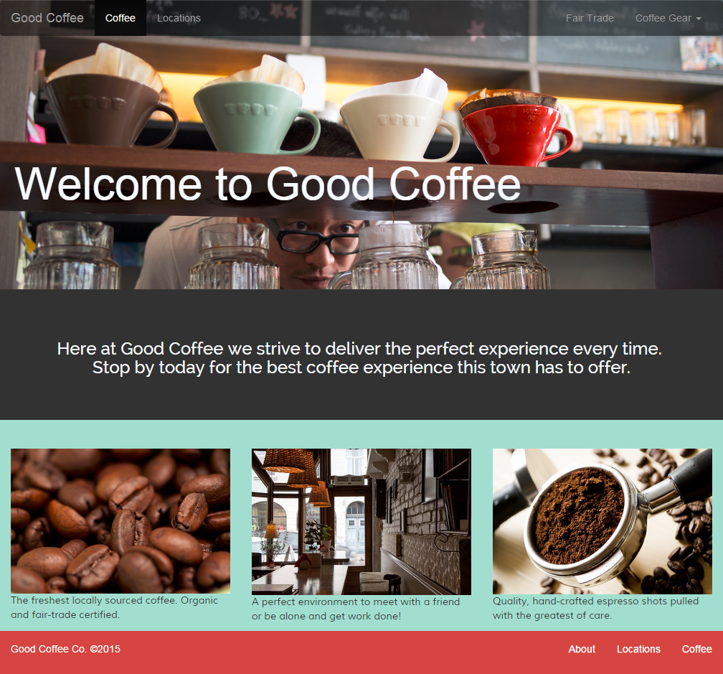

Snippet of the Coffee Gear menu at top right:

